-2-

AND WHEREAS in terms of the clause 4 of the term & conditions of the said offer of appointment, the Trainee-employee and his surety are required to execute a Service Agreement Bond on non-judicial stamp paper in favor of the Company, undertaking to complete the training and thereafter to serve the company for a period of three years falling which the Trainee-employee and the surety shall be jointly and severally bound unto the company in the sum of ₹_________________/- (Rupees

______________________________________ only) plus GST, in terms of his Bond.

NOW THEREFORE this BOND witnessed as under :-

- That the Trainee-employee shall undergo the training provided by the company for a period of one year, which may be extended at the discretion of the company during which period the trainee-employee shall diligently, faithfully and to the best of his/her ability undergo the training and conduct and behave himself/herself honestly, orderly and obediently towards his/her superiors and management of the company and will devote his/her whole time to the duties assigned to him/her by the company and will not engage directly or indirectly in any trade, business or occupation till the end of the period for which he/she is bound to serve the company.

- That the Trainee-employee shall not leave the company during the prescribed training period of one year which may be extended at the discretion of the company or during the period of service of the company for the stipulated period of three years after completion of the training except for reasons of continued serious ill health/incapacitating him/her to work provided that such ill-health has not been brought about by his/her neglect, carelessness, design or misconduct about which the decision of the company shall be conclusive and binding.

- That the Trainee-employee shall promptly obey his/her superiors and comply with their orders, instructions issued from time to time and at all times and in all respects shall faithfully observe all the Rules and Regulations of the company.

(SIGNATURE)

(SURETY)

(SIGNATURE)

TRAINEE EMPLOYEE

-3-

- That the Trainee-employee shall observe secrecy and/ in no way divulge or disclose to any person or persons what-so-ever, the secrets entrusted to him/her or coming to his/her knowledge in the course of his/her training and service with the company either in relation to its work, business or its customers.

- That the Trainee-employee shall not commit or cause to be committed and waste, damage or other injury to the property and/or goods of the company nor shall he/she lend any such property or goods to any persons without the permission of the management of the company.

- That Trainee-employee shall not participate in political activities nor shall become a member of political organizations.

- That if the trainee-employee fails to complete his/her training successfully/and or serve the company for the stipulated period of three years thereafter, the trainee – employee and the surety undertake that they shall jointly and severally compensate the company for all the expenses incurred by it on account of and in connection with his/her training. The expenditure incurred by the company on account of and in connection with the training of the trainee-employee shall include the salary, TA etc. paid to the trainee-employee during the training period, the cost of supervision, overhead and other direct and indirect expenses incurred by the company on the training. The decision of the Chairman & Managing Director/General Manager or an officer nominated by the Chairman & Managing Director shall be final and binding as to the total amount of expenditure incurred by the company on account of and in connection with the training of the trainee-employee. However, the total amount recoverable under this clause shall not exceed ₹_______________/- (Rupees ________________________________

only) plus GST. Further the trainee-employee shall on the termination of his her training/service by the company or on his/her leaving the said training/service whenever it may happen shall account for, pay and peacefully deliver to the company all the stocks in trade, books of accounts, documents, papers and effects then in his/her possession and custody and belonging or relating to the company.

(SIGNATURE)

(SURETY)

(SIGNATURE)

TRAINEE EMPLOYEE

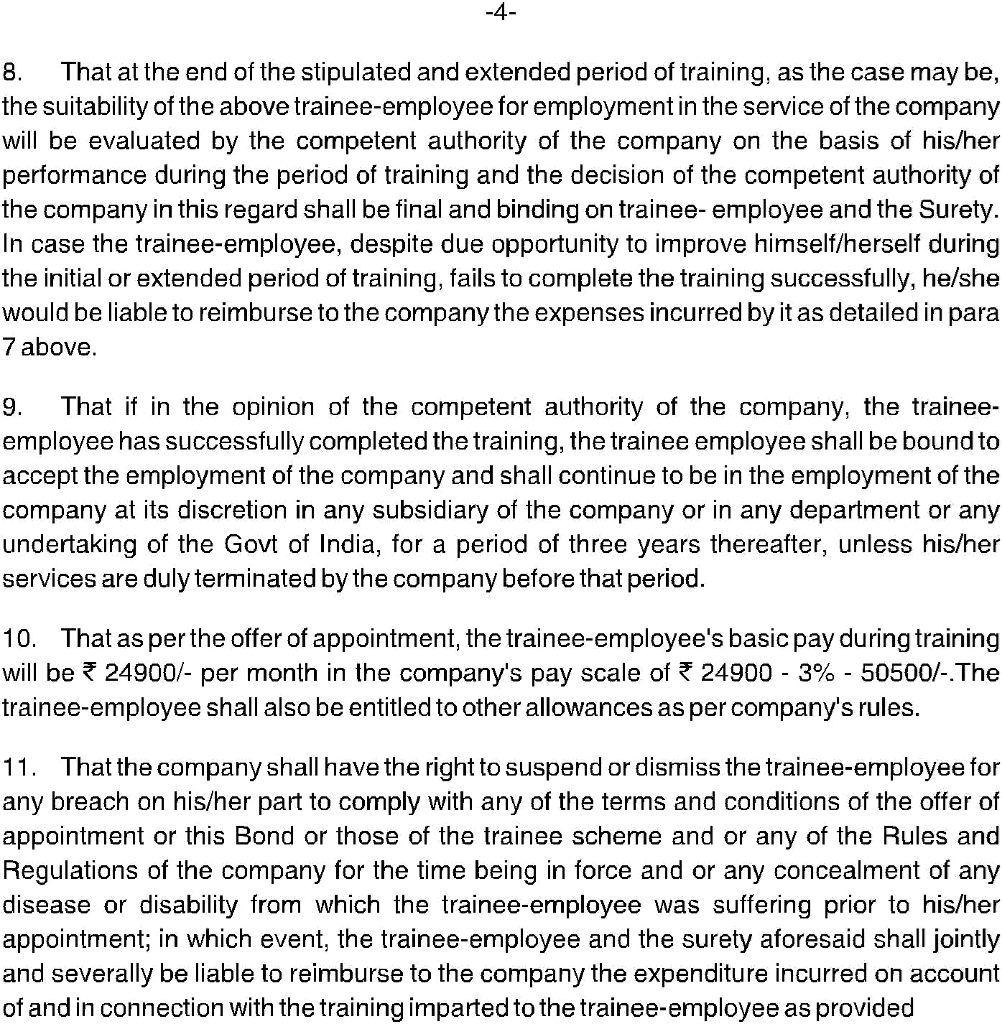


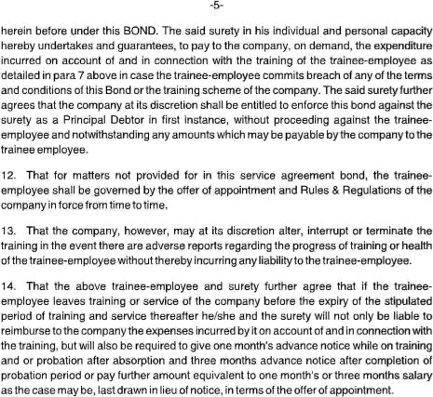

-6-

- That after completion of three years service if the trainee-employee wants to leave service of the company then he/she shall give three month’s advance notice to the company failing which he/she will also be liable to pay to the company compensation equivalent to three month’s salary.

- That in the event of insolvency, lunacy or death of the surety, the above bounden trainee-employee undertakes to intimate the company of the event with satisfactory proof thereof within 15 days of the occurrence, and shall execute a fresh bond with a fresh surety or sureties as may be acceptable to the company, without prejudice to the rights of the company to proceed against the original surety or his estate.

- That in case the trainee-employee does comply with the terms and condition contained in the offer or appointment, the Rules and Regulation of the Company and the covenants contained in this bond, the trainee-employee and his surety undertake that they shall jointly and severally pay to the company on demand without any demur the amount demanded by the company towards the expenses incurred by it on account of and in connection with the training of the trainee-employee including stipend/salary, TA/DA, passage fare, cost of supervision overhead charges, direct and indirect expenses incurred by the company, provided that the total amount recoverable on account of and in connection with the training shall not exceed ₹_______________/-(Rupees ___________________________________________ only) plus GST, plus an amount equivalent to three months salary in lieu of notice period, if any, as per offer of appointment applicable and any other amount that may be due to the company on account of other payments or on other accounts, if any.

(SIGNATURE)

(SURETY)

(SIGNATURE)

TRAINEE EMPLOYEE



